PRESS RELEASE November 2016

Cutting Edge Solution
Incredible New Use for Protein: Metalworking Cooling & Lubrication

GELITA has developed a functional protein to revolutionize the metalworking industry. GELITA, with its latest invention NOVOTEC® CL 800, facilitates the production of water-miscible synthetic and semi-synthetic metalworking fluids with combined advantages that previously seemed incompatible: Cooling power, lubrication performance and skin compatibility.

In the metalworking industry, cooling lubricants are indispensable for protecting work pieces and equipment against abrasive wear and overheating during lathing, drilling, milling or grinding. Conventional cooling lubricants are generally oil-in-water emulsions where the oil is used for lubrication and the water is used for cooling. Unfortunately, the oil does not dissipate any heat - preventing heat from being effectively transported away from the work piece. In addition, during metal processing, an oil mist that is harmful to health can be produced. Disposing of the cooling lubricant is also expensive. And due to the scarcity of oil-based raw materials, they are subject to volatile price increases.

Improved cooling and lubricating with functional proteins
Globally, thousands of tons of metal-processing lubricating concentrates are consumed each year. GELITA researchers have - in cooperation with a well-known automotive part supplier- developed the innovative protein-based liquid concentrate NOVOTEC® CL 800, an ingredient for a new generation of oil-free cooling lubricants.

“Metal working fluids based on this functional protein look like water, perform better than oil and show significantly better cooling than mineral-oil based products as they attract water to the surface rather than rejecting it like oil,” explains Dr. Matthias Reihmann, Head of Global Product Management Photo/Technical. This was demonstrated by abrasion wear tests (so-called Reichert-Test), tapping-torque measurements and surface analysis of machined aluminum pistons under lab conditions. An additional 15-month field test of a reference guideline formulation confirmed routine performance and aging stability. While developing this reference formulation, GELITA worked together with LANXESS’ Rhein Chemie Additives business unit, an expert in the area of high-performance additives for lubricants.

Improved Surface Quality:
Metal-processing fluids based on NOVOTEC® CL 800 also have an additional advantage: they leave no unwanted residues on work pieces, tools or chips. As such, processed parts can often be used for further production, such as bonding, welding, painting or coating, without the need for further intensive cleaning. Customer experiences show that the consumption of metal working fluids can be reduced by up to 40% with NOVOTEC® CL 800 due to better cooling and wetting behavior of the protein-based fluids. The residual flakes can be collected in almost dry form and re-processed without removing oil mist; reducing costs and increasing production efficiency.

Advantages for humans and machines
Among the first formulators using NOVOTEC® CL800 was Chemische Werke Kluthe GmbH in Germany. Their NOVOTEC® CL800 based product Hakuform A805 is used already by several larger customers in Germany, e.g. Heidelberger Druckmaschinen AG, where the product started in the technical training center in mid-2015. Beside technical improvements like increased lifetime of tools and a broad suitability for different materials (e.g. steel, aluminum and composites) many users reported a notable improved skin tolerance, even compared with full synthetic metalworking fluids. Christian Beck, Head of training center for technical professions. “We have used Hakuform A 805 for milling and turning. It was important for us that the metalworking fluid can be applied for different operations and materials. We process different materials almost every day such as steel, aluminum or composite materials. In addition our focus was on lifetime of tools and skin compatibility. We are very satisfied with the results. Compared to earlier times, where skin irritation was definitely an issue, we could not find a single case of skin intolerance on one of our trainees so far. There are also no odors. In addition, the new cooling lubricant is very stable and needs less maintenance due to its stability.”

About GELITA
The GELITA Group is the world’s leading manufacturer of collagen proteins, with 21 plants across all continents. In particular, products include gelatines for the production of food, pharmaceutical products and technical applications as well as collagen peptides for producing health products for joint complaints, weight reduction and cosmetics. The GELITA Group is headquartered in Eberbach, Germany. In 2015, the group of companies earned revenue of around 800 million dollars with more than 2,500 employees, thus securing their leading position on the global market.

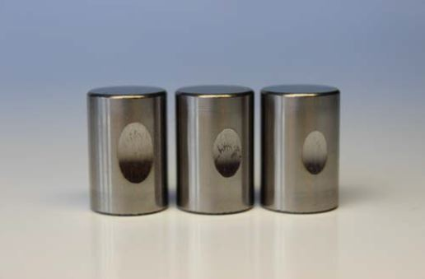
Three test rollers used in lubrication tests for abrasive wear (Reichert): Left, lubricated with water; center, using a standard cooling lubricant; right, with NOVOTEC® CL 800 (5% in each). Source: GELITA AG

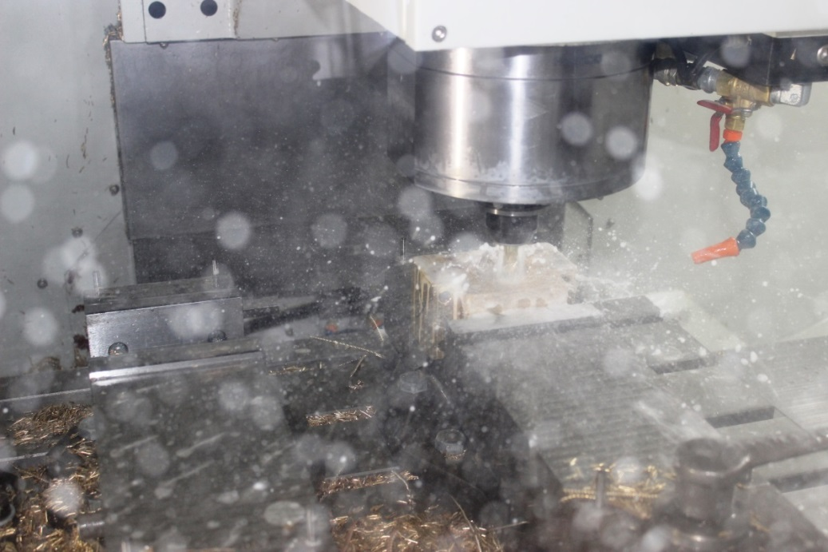
Looks like water, performs better than oil and enables the manufacture of environmentally friendly cooling lubricants: NOVOTEC® CL 800. Source: GELITA AG

https://www.gelita.com/en/products/novotec-cl800

For further information

GELITA
Lara Niemann – Marketing Director, Americas
Phone: 712 943 1692
E-Mail: lara.niemann@gelita.com
www.gelita.com

ANM Communications
Amy Maggio, Managing Director
Phone: 312 617 6248
E-Mail: amy.maggio@anmhealthcare.com

